 | Job Description | June 2026

Role: Learning Coordinator (Timesliders) | Region: North East
Reports to: Regional Director - North East | Pay Grade: Grade 4 - £33,245 pro-rata per annum
Location: Crathes Castle, Garden & Estate, Banchory, Aberdeenshire AB31 5QH / Hybrid | Type of Contract: Permanent. Part-Time, 18 Hours Per Week. (Post commencing no earlier than 1 September 2026)

JOB PURPOSE

This role will establish, develop and support delivery of our new schools programme Timesliders across a number of properties in the North East. Timesliders is an ambitious new concept for the Trust and this role will play a key part in reviewing, refreshing and developing the programme, with the aim to roll it out at other Trust properties in the future.

Working with property and national learning teams, programme developers, and teachers/schools, this role will facilitate delivery of outreach activities, create, develop and promote accompanying events and resources, and will engage schools with the project. The postholder will ensure the evaluation and reporting programme for Timesliders is implemented and will establish relationships with local schools and their communities. This post will also work closely with Visitor Services Managers at the properties to implement planning for sustained schools programmes and activities beyond the initial phase of Timesliders.

CONTEXT

At the National Trust for Scotland, we recognise the importance that learning and engagement plays in adding value to the visitor experience at our properties. In 2021, a new Formal Learning Strategy was introduced by the Trust, which aims to roll out new, consistent, high quality schools programmes across Scotland.

One of the key elements of the new programmes will be the national roll out of Timesliders. This innovative story-based programme involves digital resources, outreach resources, on-site workshops and new ways of engaging with schools in line with the Curriculum for Excellence.

Timesliders has initially been trialled at Drum Castle and Estate and this post will be involved in continued support of the programme at Drum, whilst also developing and supporting delivery of the programme at additional properties. The stories we will tell will include topics as varied as Jacobites, habitats, climate change and medieval history. This post will be at the heart of ensuring the programme reaches a range of local schools and families, including consulting with local schools and communities. This post will also lead on the creation, development and delivery of linked family events and resources to encourage return visits.

As this project is a key delivery element of the Formal Learning Strategy, this post will also work closely with the national Learning team on evaluation, reporting and development, with a dotted line to the Head of Learning. The post holder will also become a member of the Formal Learning Network, a community of practice across the Trust for staff working with schools.

KEY RESPONSIBILITIES AND ACCOUNTABILITIES

In this role the post holder will:
- Establish and support properties to deliver Timesliders, liaising with the Site Operational teams, Operations Managers, national Learning team, and other internal/external stakeholders
- Form, build, and maintain relationships with local schools
- Liaise with the Timesliders’ development team of creators, contractors, and suppliers to develop and deliver the programme’s products
- Coordinate logistical arrangements for the outreach activities
- Support properties to deliver and coordinate schools sessions on-site
- Maintain detailed records of participating schools and visits and input into reports by the national learning team
- Contribute to and coordinate evaluation of the programme, working with an external evaluation specialist and the national learning team
- Create and develop resources, guidelines and plans as required to ensure all schools programmes meets the needs of the schools
- Create, develop and deliver new family events and resources to encourage return visits
- Ensure all work is carried out in line with our Conservation principles and Safe Systems of Work (H&S)
- Carry-out any essential administrative tasks as required; e.g. raising purchase orders, contributing to monthly reports, arranging project meetings, etc.

PERSON SPECIFICATION

Essential
- Demonstrable experience in heritage/outdoor learning including:
    - Recruiting schools and building lasting relationships with schools: their management, teachers, and pupils;
    - Working with external specialists and consultants where appropriate to deliver and develop learning programmes and resources;
    - Undertaking administrative and statutory requirements to plan and document school visits
    - Undertaking evaluation of programmes and reporting as required.
- Experience in delivering sessions to schools and other groups
- Ability to work within a team and independently with minimal supervision to a high standard
- Excellent communication and interpersonal skills with a range of audiences, including key stakeholders (e.g. teachers, education professionals and pupils)
- Confident in using Microsoft Office 365, including Teams, Planner, Sharepoint, Word, Outlook and Excel
- Excellent organisational, administrative and time-management skills with the ability to prioritise and re-prioritise workload to meet changing demands
- Ability to influence, train and support colleagues in order to achieve project objectives

Desirable
- A relevant qualification in education or heritage learning, or equivalent experience
- Understanding of the needs of school visitors of all ages, abilities and interests
- Experience in developing and delivering events and resources for families and other audiences

The Trust requires the post holder to become a member of the Protection of Vulnerable Groups (PVG) scheme, which replaces the “Enhanced Disclosure” check and is administered by Disclosure Scotland.

Place in organisational chart:
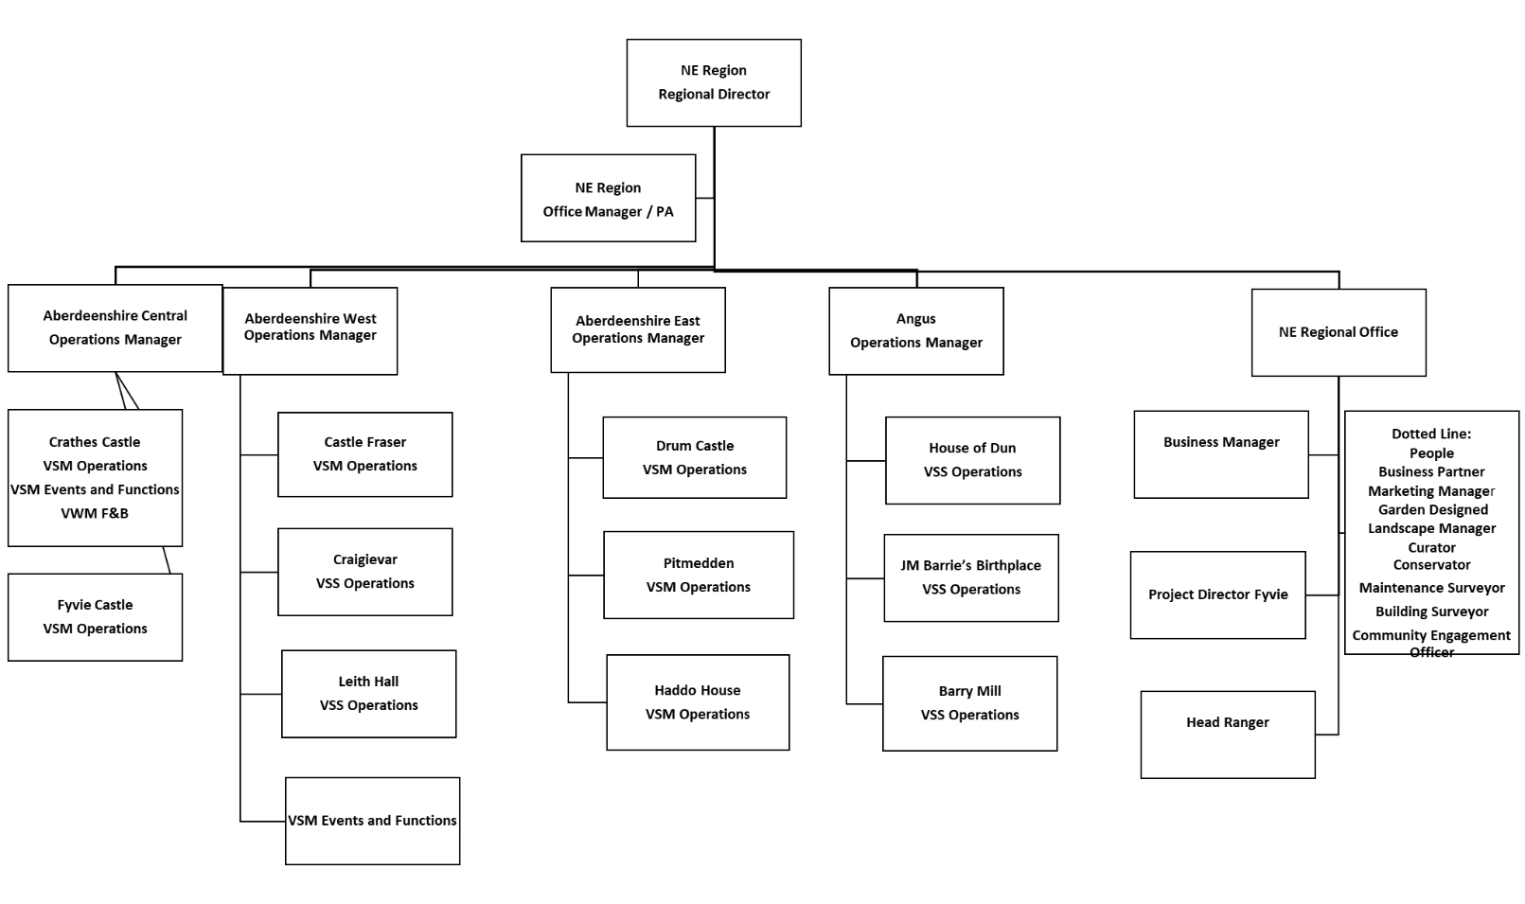
Learning Coordinator
(Dotted line to Head of Learning)

DIMENSIONS AND SCOPE OF JOB

Scale

- This role will require regular travel across the North East region.

People Management
- Will work closely with the Operations Managers, Visitor Services Managers and other VS staff, national Learning team, external contractors, and volunteers.
- Will have regular interaction with teachers and school pupils.

Finance Management
- Limited operational budget c£5k

Tools / equipment / systems
- Access to desktop PC and relevant IT systems, i.e. standard NTS management systems including Intranet, T:Drive,
- Microsoft Office 365, including Teams, Planner, Sharepoint, Word, Outlook and Excel

The Key Responsibilities, Scope of Job, and Required Qualifications, Skills, Experience & Knowledge reflect the requirements of the job at the time of issue. The Trust reserves the right to amend these with appropriate consultation and/or request the post-holder to undertake any activities that it believes to be reasonable within the broad scope of the job or their general abilities.

HOW TO APPLY

Interested applicants should forward their Curriculum Vitae (CV) or an Application Form to the People Services Department (Applications) by email via workforus@nts.org.uk by Sunday 28th June 2026.

Please ensure your CV includes your full name and contact details, the CV file sent to us should be titled your first initial and surname. When submitting your CV please state the position and job location of the vacancy you are applying for in the subject title or body of your email: For example, "Learning Coordinator – North East"

